The following is an example of a Choice Board for students to use to get their school work done during the day. The expectation is for the student to complete all of the choices, but they choose the order. The student places a magnet to indicate the choice. Edit this to work for your child using Google images.
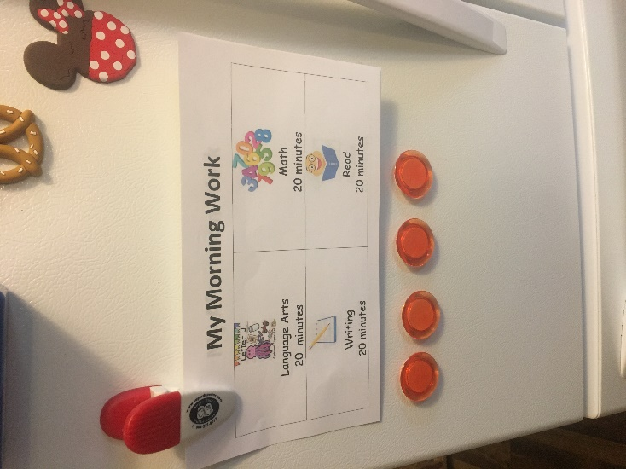
My Morning Work
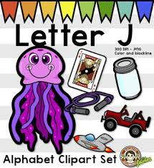  Language Arts  20 minutes | 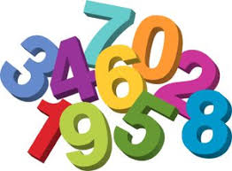  Math  20 minutes
Writing  20 minutes | Read  20 minutes

My Afternoon Work
Language Arts  20 minutes | Math  20 minutes
Read  20 minutes | Puzzles  20 minutes

